# **ADKAR Assessment worksheet**

## What is the ADKAR Model?

The Prosci ADKAR® Model is a goal-oriented change management model that guides individual and organisational change ADKAR is an acronym that represents the five tangible and concrete outcomes that people need to achieve for lasting change: *awareness*, *desire*, *knowledge*, *ability* and *reinforcement*.

By outlining the goals and outcomes of successful change, the ADKAR Model is an effective tool for planning change management activities, equipping your leaders facilitating change, and supporting your stakeholders throughout the change.

## Focusing on the people side of change

The Prosci ADKAR® Model is one of the most widely requested and sought-after models for change management. Backed by 20 years of Prosci research, the model is based on the common—yet often overlooked—reality that organisational change only happens when individuals change.

The ADKAR Model drives powerful results by supporting individual changes to achieve organisational success. The model offers a structured approach to ensure that each individual experiencing change moves through the five phases necessary to make overall change successful.

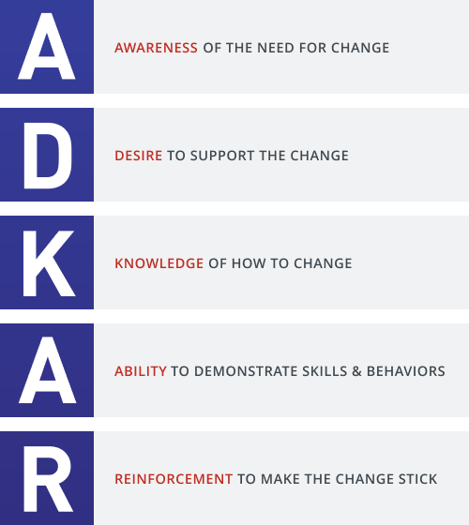

## ADKAR Assessment Worksheet

**Rank the following statements**

1 = strongly disagree, 5 = strongly agree, NA = not applicable

**Awareness**

|  |  |  |  |  |  |  |
| --- | --- | --- | --- | --- | --- | --- |
| Think about this …. | 1 | 2 | 3 | 4 | 5 | n/a |
| I understand the business reasons for the change. |  |  |  |  |  |  |
| I understand the risks of not changing. |  |  |  |  |  |  |
| I understand the impact on my day-to-day work activities. |  |  |  |  |  |  |

**Desire**

|  |  |  |  |  |  |  |
| --- | --- | --- | --- | --- | --- | --- |
| Think about this …. | 1 | 2 | 3 | 4 | 5 | n/a |
| **I am personally motivated to be part of the change.** |  |  |  |  |  |  |
| I look forward to the new, changed environment. |  |  |  |  |  |  |
| **My peers support the change.** |  |  |  |  |  |  |

**Knowledge**

|  |  |  |  |  |  |  |
| --- | --- | --- | --- | --- | --- | --- |
| Think about this …. | 1 | 2 | 3 | 4 | 5 | n/a |
| I have the skills and knowledge to be successful during the change. |  |  |  |  |  |  |
| I have the skills and knowledge to be successful after the change. |  |  |  |  |  |  |
| Training has been adequate to prepare me. |  |  |  |  |  |  |

**Ability**

|  |  |  |  |  |  |  |
| --- | --- | --- | --- | --- | --- | --- |
| Think about this …. | 1 | 2 | 3 | 4 | 5 | n/a |
| I have the ability to perform the new duties required by the change. |  |  |  |  |  |  |
| I can get support when I have problems and questions. |  |  |  |  |  |  |
| I have practice at performing in the new environment. |  |  |  |  |  |  |

**Reinforcement**

|  |  |  |  |  |  |  |
| --- | --- | --- | --- | --- | --- | --- |
| Think about this …. | 1 | 2 | 3 | 4 | 5 | n/a |
| The organisation is committed to keeping the change in place. |  |  |  |  |  |  |
| I know the consequences of not performing my new activities. |  |  |  |  |  |  |
| I am rewarded for performing in the new way. |  |  |  |  |  |  |

Transfer your scores from each ADKAR stage to the table below. Take a moment to review your cores. Highlight those areas that scored a three or less and identify the first area with scores of three of less. The first area will be your primary focus. Create a bar graph below showing your ADKAR Change Profile.

|  |  |
| --- | --- |
| **Comments on any scores below a ranking of 3** | **Score from ADKAR Worksheet** |
| **AWARENESS** of the need to change? |  |
| **DESIRE** to make the change happen? |  |
| **KNOWLEDGE** about how to change? |  |
| **ABILITY** to change? |  |
| **REINFORCEMENT** to maintain the change? |  |

Update data with your score to create your ADKAR profile graph